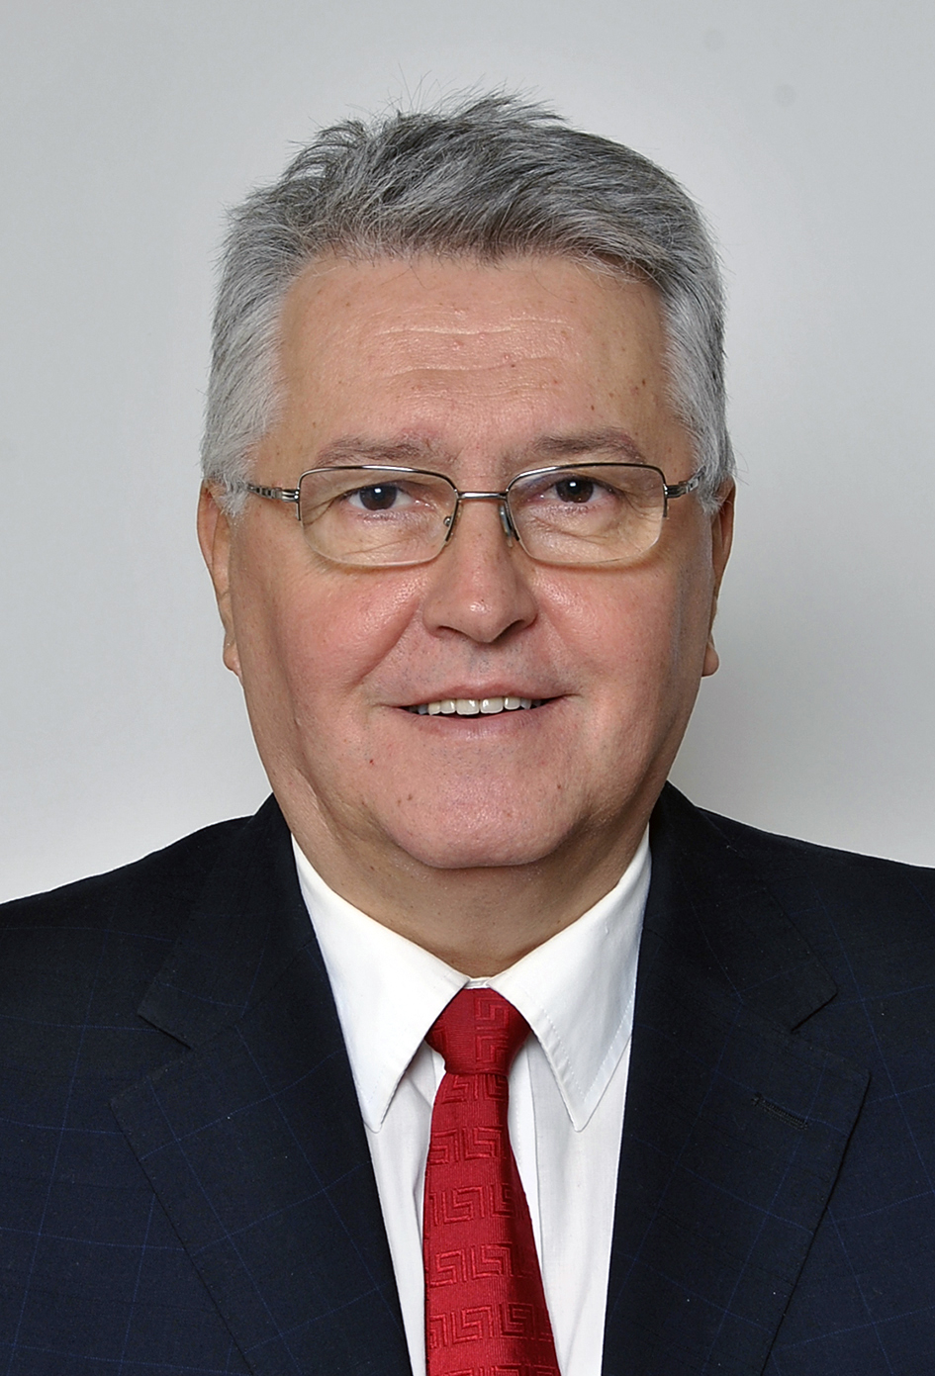 | Miloš Nedeljković, full member of Academy of Engineering Sciences of Serbia (AESS) since Dec.2015, General Secretary of AESS’s Department of Mechanical Engineering Science since Jan.2017, full professor at University of Belgrade – Faculty of Mechanical Engineering (UB-FME) since Apr.2002, Head of Chair for Hydraulic Machines and Energy Systems since Oct.2015, State Secretary at Ministry of Science and Technological Development (2008-2011), Dean of UB-FME in three mandates (2002-2008), holder of  The Order of Saint Sava of the second grade of the Serbian Orthodox Church since Jan.2008. ORCID: 0000-0001-5275-1410.
Born in Belgrade on July 26th, 1957, of father Srećko and mother Verica. Primary school and gymnasium finished in Belgrade in 1976 and graduated (Dipl.-Ing. now MSc) on UB-FME in 1980 on Department for hydropower engineering with average grade 9.78 (out of 10). In 1987 he earned a Magister, and in 1993 a PhD title (both on UB-FME) in the field of fluid machinery flow phenomena. He started employment at UB-FME in 1981 being first assistant, then 1987 Magister assistant, 1994 Dozent, 1996 Associate professor, and Full professor since 2002.

In teaching activity he lectures in several courses of the Chair at all study levels. He has been a mentor of 3 PhD theses, co-mentor in additional 2, of 2 Magister ones and over 90 diploma works (now MSc theses). He was a member of one PhD committee in Germany. Coauthor of 2 published textbooks. He contributed to development of several laboratory installations for educational purposes and published several papers on university education. He headed the process of national and international accreditation of UB-FME study programs in Serbian and English.

In scientific and research activity he works in the field of fluid machinery and applied fluid mechanics: hydraulic pumps and turbines, fans, turbocompressors, fluid flow measurements and computational fluid dynamics. He published: 5 papers-chapters in international monographs, 20 papers in international journals referenced in ISI-JCR-SCI list, 12 papers in other international journals, 41 paper in the proceedings of international conferences, 1 national monograph, etc. As evidenced by University Library papers were cited 102 times. He gave an invited lecture in 2 international conferences, in 9 was a member of program committee, and in 7 a session chairman. He is a peer reviewer of ISI-JCR-SCI journals: Trans. ASME – J Fluids Eng, Arch of Appl Mech, Exp Thermal and Fluid Science, and Advances in Mech Eng, as well as the expert evaluator of over 110 project proposals in FP7 and HORIZON-2020 calls. He participated in numerous projects of national Ministry for science, and in one was a project leader. Since Jan.2017 is a president of the Expert panel for energy, mining and energy efficiency of Ministry of Education, Science and Technological Development, and was its member in 2007-2008.

In engineering activity he worked as a coauthor in 31 engineering project, in 15 original technical designs – realized constructions (9 fans, 4 pumps, 1 turbocompressor impeller and 1 small hydro-turbine), in numerous reports on technical reviews of design projects, in studies and laboratory reports. He is a licensed engineer and member of Engineering Chamber of Serbia since its foundation in 2003. He participated in delivering solutions of numerous problems in industry and in development of new constructions. Was a chairman of the Jury for best inventions, designs and technical improvements of Belgrade Industry Chamber in 2010-2016.

In international cooperation activities he visited a lot of technical universities of various developed countries, especially through partnership in TEMPUS projects, where he was the main coordinator of one project, and in projects SCOPES and DAAD. Is a long-term member of renowned international associations GAMM, IAHR and ASME.

In management activities, he was also a UB-FME Vice-Dean for studies 2000-2002, Vice-President of the Serbian Society of Mechanics 2006-2009 (General Secretary 1997-2001), President of the Society of Metrologists 2003-2007, President of the Association of University Professors and Scientists of Serbia since 2012, etc. In Academy of Engineering Sciences of Serbia (corresponding member since 25.1.2007) was a deputy secretary in Department of Mechanical Engineering Sciences in two terms 2013-2017. Was the organizer of the Academy’s second Round table: Energy situation in Serbia – where we are and where we go, held in 2009 at UB-FME.

